**Green Synthesis of Ag-Cu Bimetallic Nanoparticles and Their Antimicrobial Application**

Major Project Submitted in

partial fulfilment of the requirement for the degree of

BACHELOR OF TECHNOLOGY

By

Katam Sushma

(20112029)



**DEPARTMENT OF BIOTECHNOLOGY**

**NATIONAL INSTITUTE OF TECHNOLOGY RAIPUR, C.G**

**(DECEMBER 2023)**

**CERTIFICATE**

It is to certify that the work contained in the project report titled “**Green Synthesis of Ag-Cu Bimetallic Nanoparticles and Their Antimicrobial Application**” by “**Katam Sushma**” has been carried out under my supervision and this work has not been submitted elsewhere for a degree.

**Dr. SHARDA BHARTI**

Assistant Professor

Department of Biotechnology

National Institute of Technology

Raipur

December, 2023

**DECLARATION**

I declare that this written submission represents my ideas in my own words and where others' ideas or words have been included, I have adequately cited and referenced the original sources. I also declare that I have adhered to all principles of academic honesty and integrity and have not misrepresented or fabricated or falsified any idea/data/fact/source in my submission. I understand that any violation of the above will be cause for disciplinary action by the Institute and can also evoke penal action from the sources which have thus not been properly cited or from whom proper permission has not been taken when needed.

KATAM SUSHMA

20112029

Date: 13-12-2023

**ACKNOWLEDGEMENTS**

We would like to thank our Project Guide **Dr. SHARDA BHARTI**, Department of Biotechnology, NIT Raipur for their consent support, help, motivation and guidance. Their constant encouragement, constructive criticism and valuable guidance have been the cause for successful completion of the project.

We gratefully acknowledge **Dr. AWANISH KUMAR**, Head of the Department, Biotechnology, NIT Raipur, for allowing us to work on this field and project in particular.

We would also like to thank **Ms. SUMAN THAKUR**, Ph.D. Scholar, Department of Biotechnology for his constant assistance and guidance. Finally, we wish to convey our warmest and deepest gratitude to our family members, to whom we owe all our achievements, and to our friends for their endless support and encouragement.

Katam Sushma

20112029

**Abstract**

Green synthesis of Silver and gold Nanoparticles (Ag-Cu NPs) was performed using the leave extract of *Tamarindus Indica.* The synthesized nanoparticles have been characterized using UV -Vis, Fourier-transform infrared spectroscopy (FTIR). The antimicrobial activities have been evaluated against Gram-positive, gram-negative strains of bacteria and fungus. The UV-vis and FTIR techniques revealed the formation of nanoparticles and the active components were adsorbed on the surface of the particles thereby stabilizing the nanoparticles. The Ag-Cu bimetallic, Ag nanoparticles inhibit the growth of both Grams-negative and Grams-positive bacteria.

**Key words:** Green synthesis, nanoparticles, bimetallic nanoparticles, reducing and capping agents, antimicrobial activities.

**Contents**

|  |  |  |
| --- | --- | --- |
| **S. No** | **Contents** | **Page No** |
| **1** | Introduction | 10 |
| **2** | Literature review | 11 |
| **3** | Materials and methods | 12-15 |
| **4** | Results and discussion | 15-18 |
| **5** | Conclusion | 18 |
| **6** | References | 19-20 |

**List of Figures**

|  |  |  |
| --- | --- | --- |
| S. No | Title | Page |
|  | leaves of Tamarindus Indica | 12 |
|  | Green synthesis of AgNO3 | 13 |
|  | synthesis of CuNPs from CuSO4.5H2O | 13 |
|  | Synthesis of BM Ag-Cu NPs at pH 5, 7, 9 respectively. | 14 |
|  | ZOI of Ag and Ag-Cu against B. subtilis | 15 |
|  | ZOI of Ag and Ag-Cu against S. aureus | 15 |
|  | ZOI of Ag and Ag-Cu against C. albicans | 15 |
|  | ZOI of Cu anf Ag-Cu against E. coli | 15 |
|  | UV-vis absorption spectra of silver nanoparticles using Tamarindus Indica leaf extract | 16 |
|  | UV-vis absorption spectra of silver – copper nanoparticles  using Tamarindus Indica leaf extract at pH 5, 7 and 9 | 16 |
|  | FT-IR of Tamarindus Indica leaf aqueous extract | 17 |
|  | FT-IR of Ag-Cu Bimetallic nanoparticles | 17 |

**List of Tables**

|  |  |  |
| --- | --- | --- |
| S. No | Title | Page |
| 1. | Green synthesis sources for AgNPs, CuNPs, BM Ag-Cu NPs synthesis | **11** |

**Abbreviations, Notations and Nomenclature**

NPs - Nanoparticles

BM NPs - Bimetallic Nanoparticles

AgNPs - Silver Nanoparticles

CuNPs - Copper Nanoparticles

Ag-Cu NPs - Silver – Copper Nanoparticles

AgNO­3 - Silver Nitrate

CuSO4 - Copper Sulphate Pentahydrate

NA - Nutrient Agar

YPD - yeast extract peptone dextrose

FTIR - Fourier transform infrared

XRD - X-Ray diffraction analysis

ZOI - Zone of Inhibition

TI - *Tamarindus Indica*

**Objectives:**

* Green Synthesis of Silver nanoparticles, Copper nanoparticles and Silver- Copper Bimetallic Nanoparticles using leaf extract.
* Characterization of synthesized nanoparticles.
* Evaluation of Antimicrobial activity of synthesized silver, Copper, Silver-Copper Nanoparticles.

1. **Introduction**

Different Nanoparticles including mono metallic, bi metallic, tri metallic and quad metallic nanoparticles can be synthesized by using plant extracts including leaf, flower, root, peel and fruit extract. The plant extract acts as reducing and stabilizing agents that reduces the metal salts into pure metals. (Idris & Roy, [2023](../Desktop/Bimetallic%20nanoparticles/crystals-13-00637-v4.pdf)).

Combination of two metal salt solutions in the presence of reducing agents and stabilizing agents will produce bimetallic nanoparticles which show new properties due to the synergy between those two metals. When compared to monometallic, the physical and chemical properties of bimetallic nanoparticles will be different and more effective. Different physicochemical methods have been employed for the synthesis of bimetallic nanoparticles. The synthesis of these bimetallic nanoparticles through environmentally benign methods is more attractive and promising due to the production of non-toxic, cost-effective, and high-quality nanoparticles through these methods. Green synthesis of nanoparticles can be affected by various factors such as parts of the plant, the solvent used for extraction, pH of the solution, salt concentration, and reaction temperature (Al-Haddad et al., [2020](../Desktop/Bimetallic%20nanoparticles/s10098-019-01765-2.pdf)).

Different properties such as electrical, physical, optical, and chemical significantly affect the size and shapes of NPs. silver nanoparticles (AgNPs) have been the most widely used antibacterial agents in the healing of wounds, bandages, and medication. Green synthesis is the method by which the NPs are synthesized using plant extract as a reducing and stabilizing mediator. These plant mediators include Citric acid, saponins, flavonoids, tannins, phenols, Ascorbic acids, dehydrogenases, and extracellular electron shuttles that directly reduce the metal ions into stable NPs. Nowadays, plant-based synthesis of Ag, Au NPs, and Ag/Au BNPs is emergent because of its simplicity, cost-effectiveness, and environmentally friendly synthesis protocols (Sher et al., [2022](../Downloads/molecules-27-07895-v2.pdf)).

The metal NPs have an intense colour in the UV-Visible region due to the surface plasmon resonance band arises from the coherent existence of free electrons in the conduction band, which are useful in catalysis, biological labelling and monitoring the tumor growth. The synthesis of bi-and tri-metallic NPs receiving considerable attention because of their widespread application in various field of human life. The structure of NPs such as alloy, core-shell, hetero structure and multi shell mainly depends on the reduction potential of metal ions as well as coordinating nature of the reducing agent (Al-Asfar et al., [2018](../Desktop/Bimetallic%20nanoparticles/GS%20of%20Ag%20Fe%20NPs%20antimicrobial%20activity.pdf))

1. **Literature review**

Synthesis of Silver – copper bimetallic nanoparticles: Green synthesis of nanoparticles can be affected by various factors such as parts of the plant, the solvent used for extraction, pH of the solution, salt concentration, and reaction temperature. The solvent used for the extraction of phenolic content from the leaves has an important role in determining the quality and yield of the extraction process. The extraction process accumulates the active components of the plant biomass using selective solvent at standard conditions (Al-Haddad et al., 2020). ‘Capping reagent’ is another important compound used in nanoparticles synthesis to prevent the overgrowth and aggregations of the particles, thereby controlling their structural properties (Phan & Nguyen, 2017).

Bimetallic nanoparticles have been significantly applied in various areas such as catalysis, biomedical, electronics, and wastewater treatment (Mohamad et al., 2013). The bimetallic copper–silver nanoparticles have shown much research interest for the development of low-cost and high-performance catalysts due to their unique chemical and physical properties. (Verma et al., 2017).

During last few years, various eco-friendly ways are determined to synthesise Silver, copper and silver copper bimetallic nanoparticles. Table 1 summarize the green synthesis sources used for production of AgNPs, CuNPs, BM Ag-Cu NPs.

**Table 1: Green synthesis sources for AgNPs, CuNPs, BM Ag-Cu NPs synthesis**

|  |  |  |  |  |
| --- | --- | --- | --- | --- |
| **Source** | **Tpye of Nanoparticle** | **Species name** | **Size Range (nm)** | **Refs.** |
| Plant-based compounds and derivatives | CuNPs | *Celastrus paniculatus* (leaf)  *Citrus limon* (fruit) | 2-10  ~30nm | [4]  [3] |
| AgNps | *Hibiscus rosa sinensis*  *Eugenia roxburghii*  *Kigelia africana* (fruits) | ~13  24  10 | [11]  [5]  [13] |
| Ag-Cu NPs | *Phoenix dactylifera (palm tree leaves)*  *Kigelia africana* (fruits) | 26  10 | [2]  [13] |

1. **Materials and methods:**
   1. **Chemicals and reagents**

Silver Nitrate (AgNO3)

Copper Sulphate pentahydrate

Nutrient Agar Broth

YPD Agar media

Ethanol

Distilled water

Centrifuge

Autoclave

Incubator

Laminar air flow

* 1. **Preparation of *Tamarindus Indica* leaf extract**

Plant leaves of *Tamarindus Indica* are collected, washed, dried and then boiled for collecting the reducing and stabilizing agents present in the leaves that help in reduction of metal salts to pure metals. 30gm of freshly washed leaves are dissolved in 300ml of distilled water, boiled on hot plate at 60 º c for 20 min. The prepared extract was filtered using Whatman filter paper. The filtrate was used immediately or stored at 4 º c for further use.

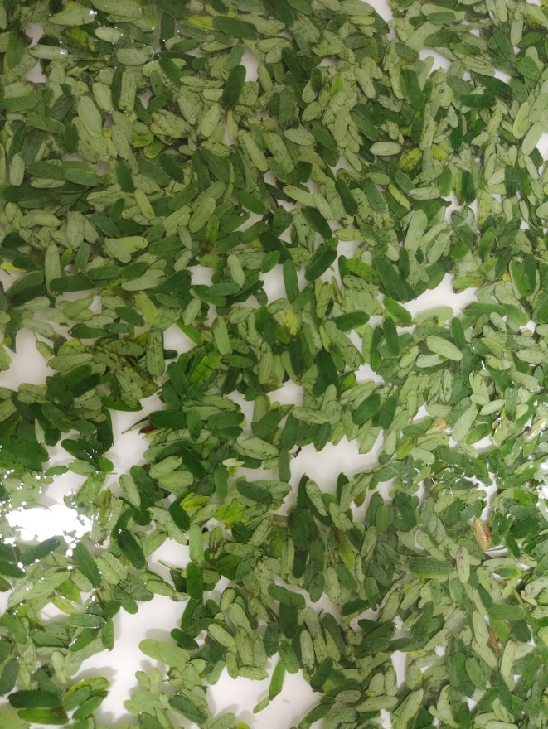

Figure 1: leaves of *Tamarindus Indica*

* 1. **Green synthesis of Silver Nanoparticles (AgNPs)**

100ml of 10mm silver nitrate (agno3) solution is prepared. Place the solution on magnetic stirrer at 37º C. 20ml of plant extract is added to the solution. The pH value is adjusted to 7 by adding 1N NaOH. The colour changes from transparent to brown colour. Place the solution incubator for overnight for UV Spectra characterization.

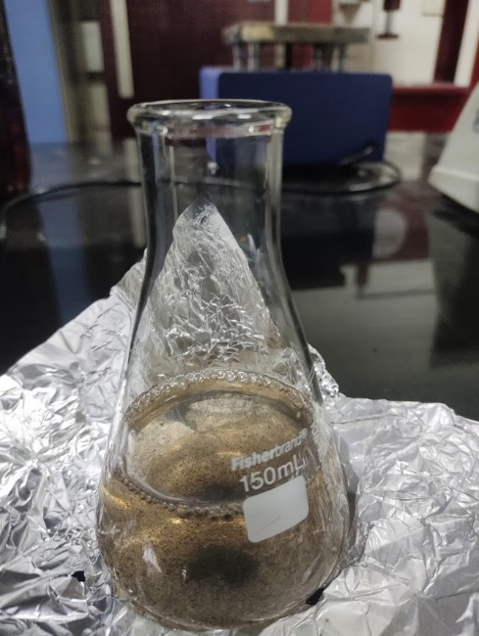

Figure 2: Green synthesis of AgNO3

* 1. **Green Synthesis of Copper Nanoparticles (CuNPs)**

100 ml of 10mm copper sulphate (cuso4) solution is prepared and place solution on magnetic stirrer at 37º C. 5 ml of plant extract is added to the solution. The pH value is adjusted to 7 by the addition of NaOH (1N) solution. The colour changes from light yellow to green is observed. Placed in incubator for overnight. Next day, the UV spectra of synthesized cu nanoparticles is taken. Around 15ml of the same solution is centrifuged and dried in hot air oven for 16hrs for FTIR characterization.

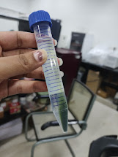

Figure 3: synthesis of CuNPs from CuSO4 5H2O

* 1. **Green synthesis of Ag-Cu Bimetallic nanoparticles:**

45ml of 5mm CuSO4, 45ml of 5mm AgNO3 and 10 ml of plant extract are added and mixed well on magnetic stirrer. The solution is adjusted at different pH 5 (acidic), pH 7 (neutral) and pH 9 (basic) - pale yellow, brown and pale orange are the respective colour changes observed as shown in figure. Place the mixtures in incubator shaking for UV Spectra characterization. Around 15ml of the same solution is centrifuged and dried in hot air oven for 16hrs for FTIR characterization.

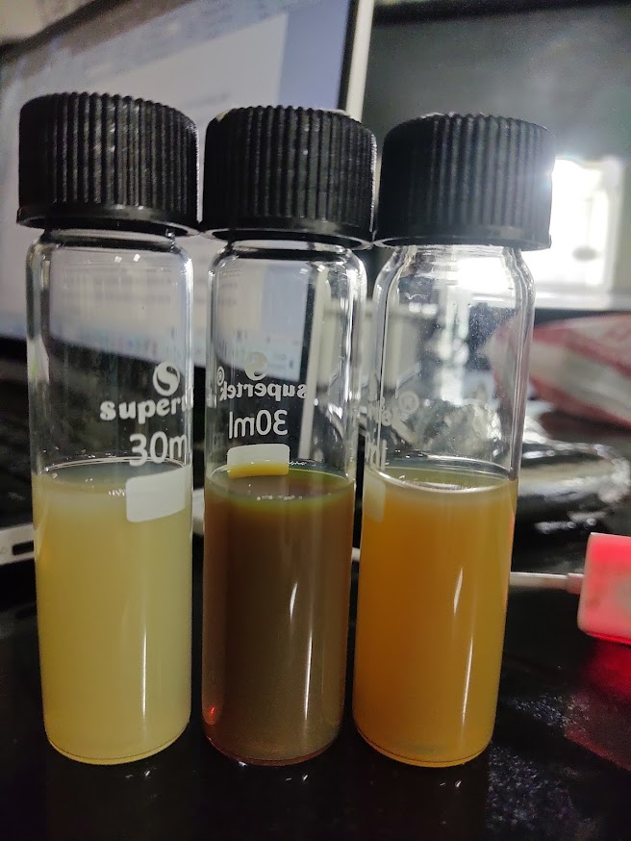

Figure 4: Synthesis of BM Ag-Cu NPs at pH 5, 7, 9 respectively.

**Antimicrobial activity**

Antimicrobial activity is evaluated by disc-diffusion assay technique against gram-positive (Bacillus subtilis, Staphylococcus aureus), gram-negative (Escherichia coli) and Fungi (Candida albicans – genus of yeasts). Firstly, 250ml of NBA media, 125ml of YPD Agar broth is prepared using deionized water (Sterile). Sterilized media, petri plates at standard condition (121◦C, 15psi for 15 min) are used during antimicrobial activity in laminar air flow. The media is transferred into Petri plates and 100μL diluted colonies were spread on the plates having solidified media using spread plate technique. Now 3mm disc (cut from filter paper) is placed on the spread plates and 50μL of each nanoparticle (Cu, Ag-Cu) are added onto the disc and incubated at 37◦C for 24h. Zone of inhibition appeared as clean area around the well was measured.

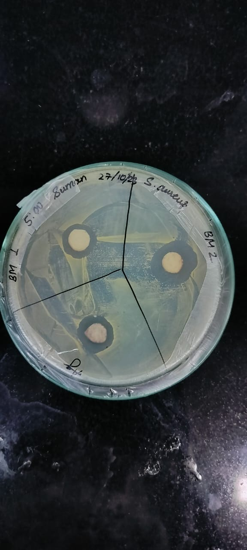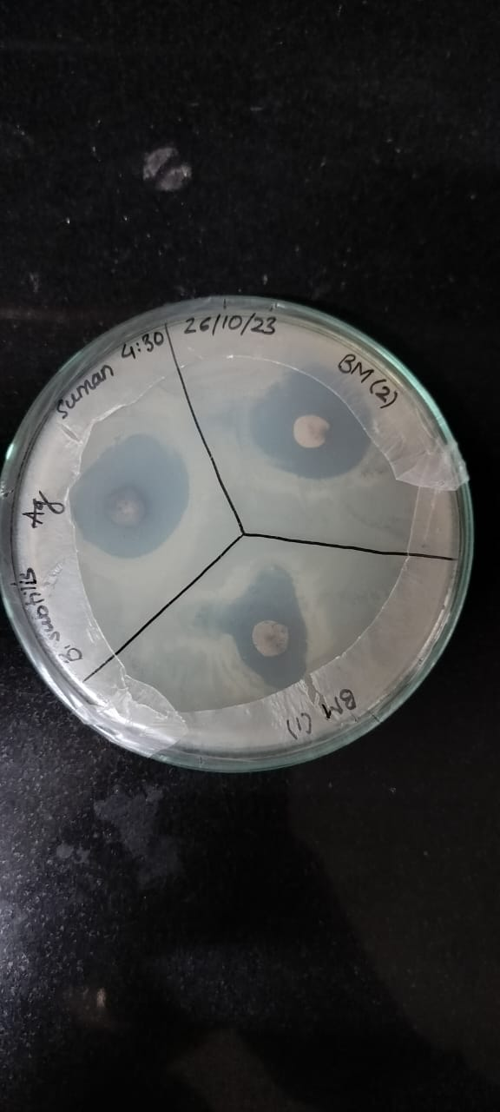

Figure 5: ZOI of Ag and Ag-Cu against Figure 6: ZOI of Ag and Ag-Cu

B. subtilis against S. aureus

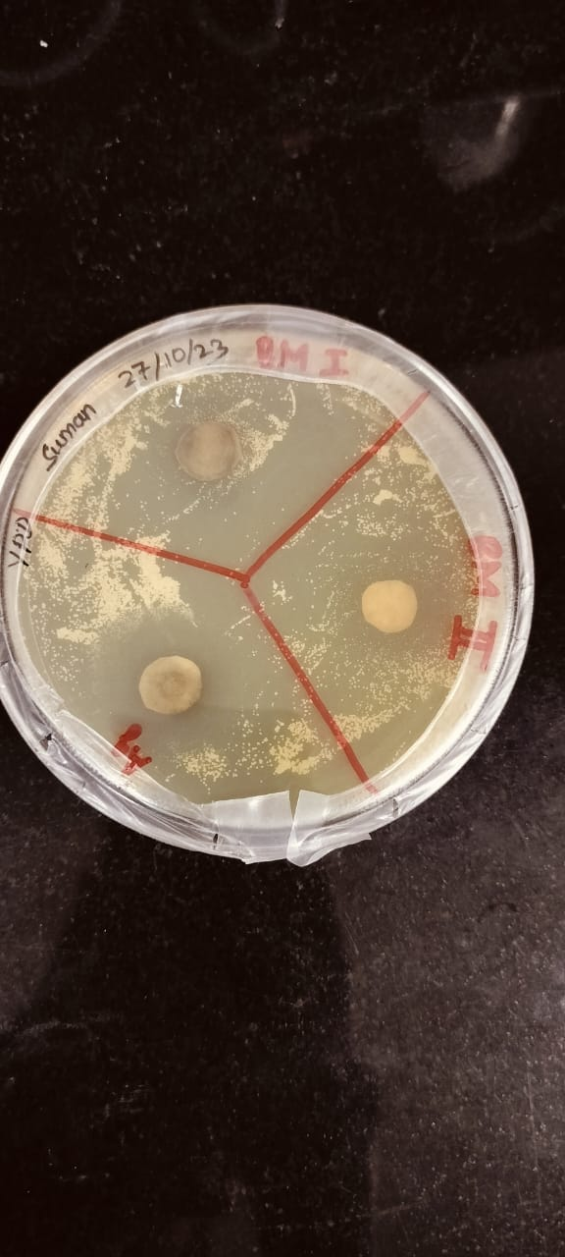 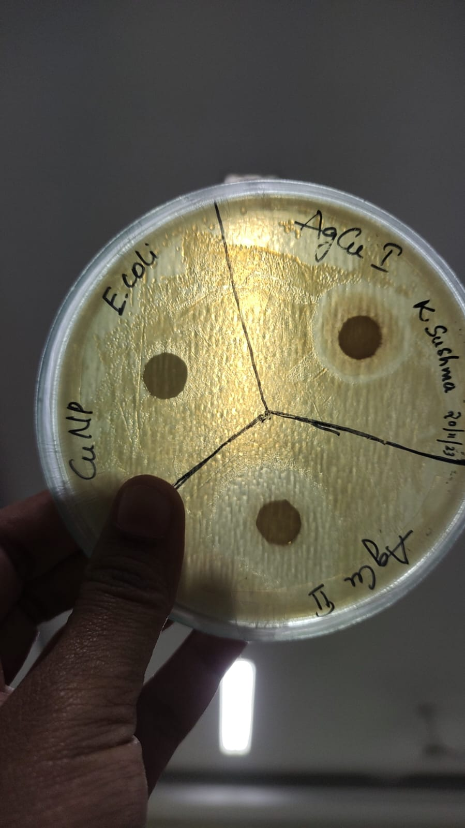

Figure 7: ZOI of Ag and Ag-Cu against Figure 8: ZOI of Cu and Ag-Cu

C. albicans against E. coli

1. **Results and discussion**

**UV – Vis analysis**

Ultraviolet (UV) spectroscopy is a technique used to analyse the absorption or transmission of ultraviolet light by a sample as a function of wavelength. The absorption bands are directly related to the size of the metal nanoparticles. The absorption spectra green synthesized BM-AgCu- NPs, AgNPs, CuNPs were recorded in the range of 200–800 nm using UV–Vis spectrophotometer. Samples are diluted accordingly using deionized water. The UV absorption peaks were observed at 432nm for AgNPs, 365nm for CuNPs and 444 nm for AgCu BM NPs.

Figure 9: UV-vis absorption spectra of silver nanoparticles

using *Tamarindus Indica* leaf extract

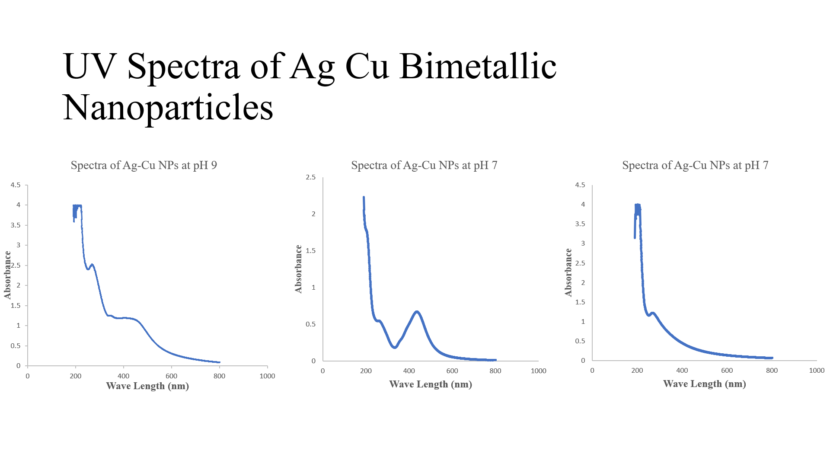

Figure 10: UV-vis absorption spectra of silver – copper nanoparticles

using *Tamarindus Indica* leaf extract at pH 5, 7 and 9

**FT-IR analysis**

FTIR is particularly useful for identifying functional groups in organic and inorganic compounds. Different types of chemical bonds, such as C=O, C-H, N-H, and O-H, exhibit characteristic absorption peaks in the infrared spectrum. FT- IR spectrum (Fig) obtained for *Tamarindus Indica* extract display two different absorption peaks, reflecting its complex nature. Strong broad peak at 3285 cm-1 indicating hydrogen bonded O-H groups of alcohols, phenols and the N-H of amide. The band at 1636 cm-1 attributed to O-H stretching. FT- IR spectrum (Fig) obtained for BM Ag-Cu NPs display two different absorption peaks, reflecting its complex nature. Strong broad peak at 3288 cm-1 indicating hydrogen bonded O-H groups of alcohols, phenols and the N-H of amide. The band at 1637 cm-1 attributed to O-H stretching. FT- IR spectrum (Fig) obtained for AgNPs display two different absorption peaks, reflecting its complex nature. Strong broad peak at 3295 cm-1 indicating hydrogen bonded O-H groups of alcohols, phenols and the N-H of amide. The band at 1656 cm-1 attributed to O-H stretching.

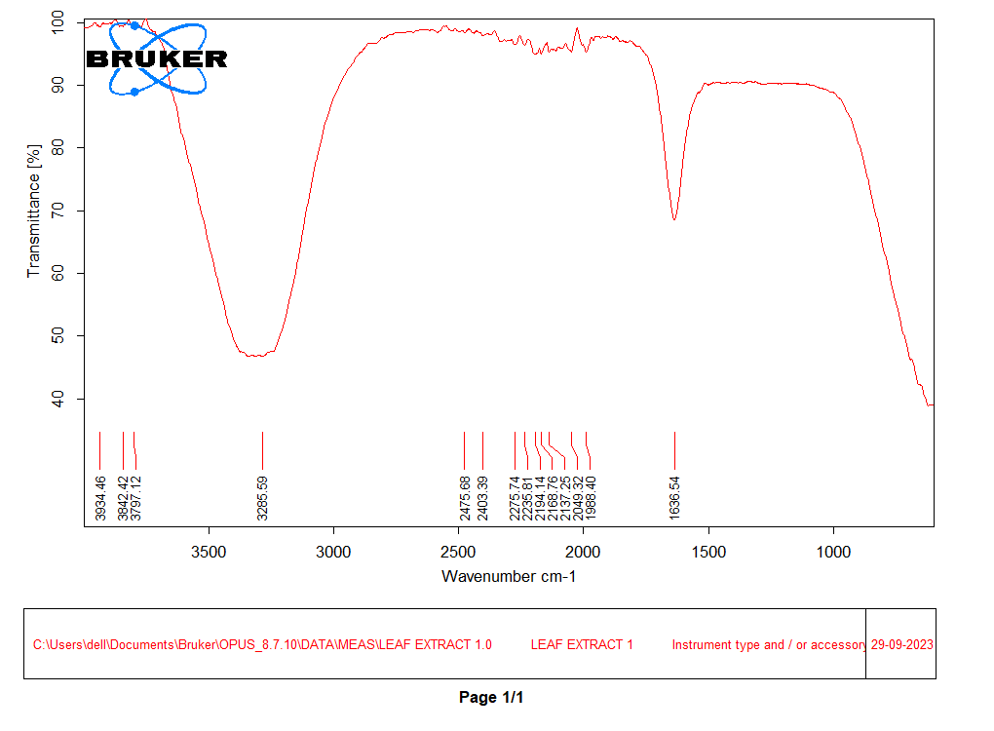

**1636**

**3285**

Figure 11: FT-IR of *Tamarindus Indica* leaf aqueous extract

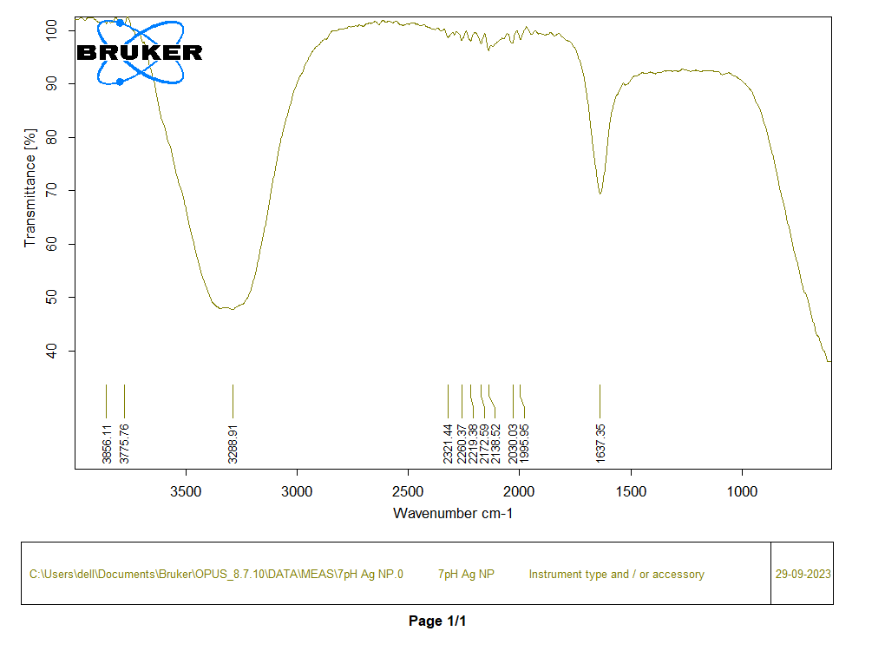

**1637**

**3288**

Figure 12: FT-IR of Ag-Cu Bimetallic nanoparticles

**Antimicrobial activity evaluation**

It is clearly observed that the discs exhibit strong Zone of Inhibition against bacterial growth with respect to three strains of B. subtilis, E coli, S. aureus, conforming that excellent antibacterial property of surfaces of the developed Ag-Cu nanoparticles. Due to the over growth of C. albicans, zone of inhibition is not found. Due to the instability of Cu NPs for longer time, the zone of inhibition is not formed. The cell surface of gram- positive Bacillus subtilis has an abundant concentration of carboxyl and amine functional groups which have a strong affinity for copper ions. The binding of copper ions with the bacterial DNA causes disorders of the helical structure through cross-linking of the nucleic acid strands. This interrupts various biochemical processes of the organism causing fatality. For the gram-negative Escherichia coli, the accumulation of silver ions pitted the cell wall structure causing the continual release of membrane proteins and lipopolysaccharides which leads to the death of the bacteria (Al-Haddad et al., [2020](../Desktop/Bimetallic%20nanoparticles/s10098-019-01765-2.pdf)).

1. **Conclusion**

Ag Cu Bimetallic nanoparticles are successfully synthesized by ecofriendly, rapid and simple green synthesis method using aqueous extract of *Tamarindus Indica*. These NPs were characterized by the following techniques: UV-vis spectroscopy, FTIR. For antimicrobial activity, this investigation revealed that Ag-Cu BM NPs have better antimicrobial activity than TI plant extract, TI-AgNPs, and TI-CuNPs. The particle size and yield of the resultant bimetallic nanoparticles have a significant effect on the operational parameters such as type of solvent, pH of the plant extract, salt concentration, and the solution temperature. An excellent antibacterial ability to show that the zone of inhibition was almost similar for both gram-positive and gram-negative bacteria. Thus, a cost-effective, non-toxic, and green technique to produce high-quality copper–silver bimetallic nanoparticle system is reported.

1. **References**

**[1].** Al-Asfar, A., Zaheer, Z., & Aazam, E. S. (2018). Eco-friendly green synthesis of Ag@Fe bimetallic nanoparticles: Antioxidant, antimicrobial and photocatalytic degradation of bromothymol blue. *Journal of Photochemistry and Photobiology B: Biology*, *185*, 143–152. https://doi.org/10.1016/j.jphotobiol.2018.05.028

[2]. Al-Haddad, J., Alzaabi, F., Pal, P., Rambabu, K., & Banat, F. (2020). Green synthesis of bimetallic copper–silver nanoparticles and their application in catalytic and antibacterial activities. *Clean Technologies and Environmental Policy*, *22*(1), 269–277. https://doi.org/10.1007/s10098-019-01765-2

[3]. Amer, M. W., & Awwad, A. M. (2021). Green synthesis of copper nanoparticles by Citrus limon fruits extract, characterization and antibacterial activity. *International Scientific Organization*, *7*(1), 1–8. https://doi.org/10.5281/zenodo.4017993

[4]. Dhaka, A., Githala, C. K., & Trivedi, R. (2020). Green synthesis of copper nanoparticles using Celastrus paniculatus Willd . leaf extract and their photocatalytic and antifungal properties. *Biotechnology Reports*, *27*, e00518. https://doi.org/10.1016/j.btre.2020.e00518

[5]. Giri, A. K., Jena, B., Biswal, B., Pradhan, A. K., Arakha, M., Acharya, S., & Acharya, L. (2022). Green synthesis and characterization of silver nanoparticles using Eugenia roxburghii DC. extract and activity against biofilm-producing bacteria. *Scientific Reports*, *12*(1), 1–9. https://doi.org/10.1038/s41598-022-12484-y

[6]. Idris, D. S., & Roy, A. (2023). Synthesis of Bimetallic Nanoparticles and Applications—An Updated Review. *Crystals*, *13*(4). https://doi.org/10.3390/cryst13040637

[7]. Liu, W. T. (2006). Nanoparticles and their biological and environmental applications. *Journal of Bioscience and Bioengineering*, *102*(1), 1–7. https://doi.org/10.1263/jbb.102.1

[8]. Mohamad, N. A. N., Jai, J., Arham, N. A., & Hadi, A. (2013). A short review on the synthesis of bimetallic nanoparticles using plant extract. *Proceedings - 2013 IEEE International Conference on Control System, Computing and Engineering, ICCSCE 2013*, 334–339. https://doi.org/10.1109/ICCSCE.2013.6719985

[9]. Nazeruddin, G. M., Prasad, R. N., Shaikh, Y. I., & Shaikh, A. A. (2014). Synergetic effect of Ag-Cu bimetallic nanoparticles on antimicrobial activity. *Der Pharmacia Lettre*, *6*(3), 129–136.

[10]. Phan, C. M., & Nguyen, H. M. (2017). Role of Capping Agent in Wet Synthesis of Nanoparticles. *Journal of Physical Chemistry A*, *121*(17), 3213–3219. https://doi.org/10.1021/acs.jpca.7b02186

[11]. Philip, D. (2010). Green synthesis of gold and silver nanoparticles using Hibiscus rosa sinensis. *Physica E: Low-Dimensional Systems and Nanostructures*, *42*(5), 1417–1424. https://doi.org/10.1016/j.physe.2009.11.081

[12]. Prakash, M., Kavitha, H. P., Abinaya, S., Vennila, J. P., & Lohita, D. (2022). Green synthesis of bismuth based nanoparticles and its applications - A review. *Sustainable Chemistry and Pharmacy*, *25*(April 2018). https://doi.org/10.1016/j.scp.2021.100547

[13]. Providence, B. A., Chinyere, A. A., Ayi, A. A., Charles, O. O., Elijah, T. A., & Ayomide, H. L. (2018). Green synthesis of silver monometallic and copper-silver bimetallic nanoparticles using Kigelia africana fruit extract and evaluation of their antimicrobial activities. *International Journal of Physical Sciences*, *13*(3), 24–32. https://doi.org/10.5897/ijps2017.4689

[14]. Rafique, M., Sadaf, I., Rafique, M. S., & Tahir, M. B. (2017). A review on green synthesis of silver nanoparticles and their applications. *Artificial Cells, Nanomedicine and Biotechnology*, *45*(7), 1272–1291. https://doi.org/10.1080/21691401.2016.1241792

[15]. Sher, N., Alkhalifah, D. H. M., Ahmed, M., Mushtaq, N., Shah, F., Fozia, F., Khan, R. A., Hozzein, W. N., & Aboul-Soud, M. A. M. (2022). Comparative Study of Antimicrobial Activity of Silver, Gold, and Silver/Gold Bimetallic Nanoparticles Synthesized by Green Approach. *Molecules*, *27*(22), 1–24. https://doi.org/10.3390/molecules27227895

[16]. Singh, A. K. (2022). Flower extract-mediated green synthesis of bimetallic Cu[sbnd]Zn oxide nanoparticles and its antimicrobial efficacy in hydrocolloid films. *Bioresource Technology Reports*, *18*(March), 101034. https://doi.org/10.1016/j.biteb.2022.101034

[17]. Verma, A. D., Pal, S., Verma, P., Srivastava, V., Mandal, R. K., & Sinha, I. (2017). Ag-Cu bimetallic nanocatalysts for p-nitrophenol reduction using a green hydrogen source. *Journal of Environmental Chemical Engineering*, *5*(6), 6148–6155. https://doi.org/10.1016/j.jece.2017.11.057

[18]. Xia, B., He, F., & Li, L. (2013). Preparation of bimetallic nanoparticles using a facile green synthesis method and their application. *Langmuir*, *29*(15), 4901–4907. https://doi.org/10.1021/la400355u